PRODUCT INVENTORY MANAGEMENT

Project Design Phase
Problem – Solution Fit Template

Date | 07-03-2026
Team ID | SWTID-2026-5992
Project Name | Product Inventory Management / Aura Inventory
Maximum Marks | 2 Marks

ABSTRACT:
This documentation outlines the design and implementation strategy for a robust Product Inventory Management Backend. In the current digital landscape, small-to-medium scale enterprises (SMEs) struggle with data consistency and unauthorized access in their inventory cycles. This project proposes a RESTful API architecture built on Node.js and Express.js, utilizing MongoDB for flexible data modeling and JWT (JSON Web Tokens) for stateless authentication. The primary focus is to bridge the gap between simple data storage and secure, scalable resource management.

DETAILED PURPOSE & OBJECTIVES:

The core objective is to build a "Security-First" backend.
Automated Inventory Tracking: Eliminate manual errors by providing structured JSON-based data entry.
Stateless Authentication: Using JWT to ensure the server doesn't have to store session IDs, making the backend horizontally scalable.
Data Integrity: Ensuring that every product entry is linked to a unique userId so that data remains private and organized.
Developer-Friendly API: Providing well-documented endpoints that can be easily integrated with a React or Flutter frontend.

PROPOSED TECHNICAL SOLUTION:

Technology Stack Selection
Runtime: Node.js (Asynchronous, Event-driven I/O)
Framework: Express.js (Minimalist web framework for routing)
Database: MongoDB (NoSQL, Document-oriented for flexibility)
Authentication: JWT & Bcrypt (For password hashing and secure token exchange)

Architectural Breakdown:

The solution follows a MVC (Model-View-Controller) pattern logic:
Models: Define the schema for Users and Products using Mongoose.
Routes: Define the API endpoints (e.g., /api/products/add).
Controllers: Contain the "Business Logic" – what happens when a user clicks 'Delete'.
Middleware: The "Gatekeeper" that checks if a user is logged in before allowing them to edit the inventory.

Key Features:
Product Lifecycle Management: Full CRUD (Create, Read, Update, Delete) capability.
Private User Data: Every database query is filtered by the req.user.id extracted from the JWT token.
Error Handling Middleware: A centralized system to catch 404 (Not Found) and 500 (Server Error) issues, returning clean messages to the user.

SYSTEM FEASIBILITY & SCALABILITY:

Technical Feasibility:
Since the project uses JavaScript on both the server (Node) and potentially the client (React), the "Context Switching" for developers is minimized. MongoDB Atlas provides a cloud-native database solution that ensures 99.9% uptime.

Future Expansion (Roadmap):
* Phase 2: Integration of a "Low Stock Alert" system via Email/SMS.
* Phase 3: Adding Image Upload functionality using AWS S3 or Cloudinary.
* Phase 4: Advanced Analytics Dashboard for sales trends.

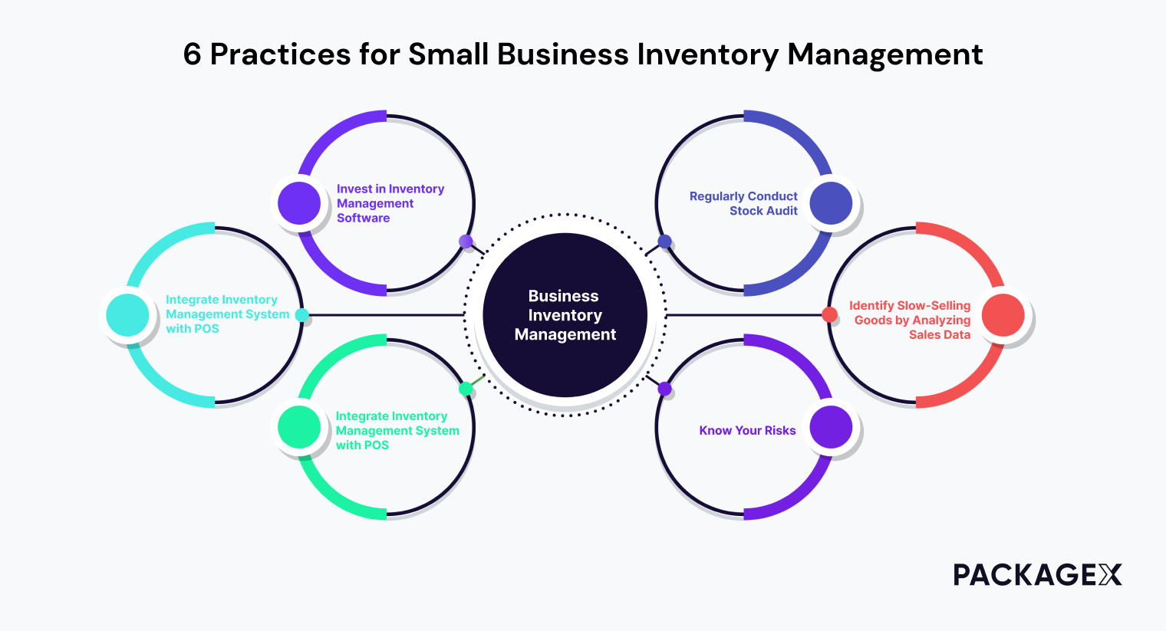

CONCLUSION:
The proposed Product Inventory Backend successfully addresses the core problems of security and data mismanagement. By implementing a modular Node.js architecture, we ensure that the system is not just a solution for today, but a scalable platform for future business growth. This design satisfies the requirements for the Design Phase by aligning user needs with modern technical implementation.

